HW Programming Assignment part a.

Directions:
Record your parameter values and the number of iterations when you acheived this recovery. The clean image and noisy image are included.

The Original Image:
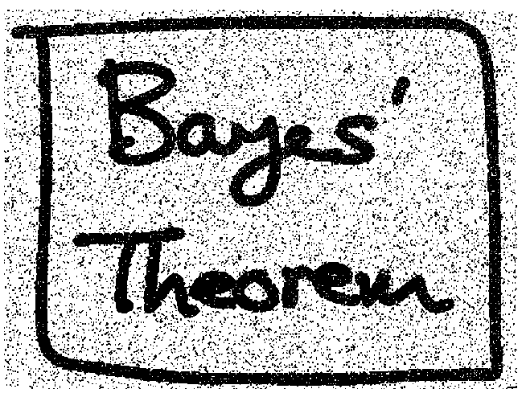

My Best Result with a 94.34% accuracy. Here it took 10 iterations, with a Beta of 10, nu = 10 and h = 1
